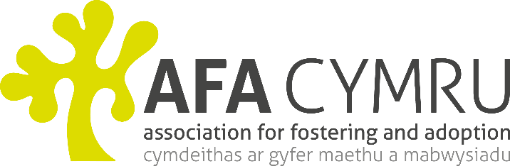
Senior Regional Administrator - AFA Cymru
37 hours
Salary: £21,074 - £24,657 SCP 22-27
Fixed Term for 2 years

AFA Cymru which is part of St. David’s Children Society provides training, consultancy, advice and information services to professionals and members of the public on all matters pertaining to children and young people.

We require an energetic and forward-thinking administrator to take a lead role in the provision of administrative support and event organisation for the AFA Cymru team in the Cardiff office. Applicants must have a minimum of 3 years’ experience with high level competence in word, excel and powerpoint

Closing date for applications is 31st January 2019. Interviews to be held on 12th February 2019.

For an informal discussion contact: Kathy S’Jacob or Helen Hawksworth Tel No: 029 2076 1155 or
email: cardiff-afacymru@stdavidscs.org

Job Description
Application Form

