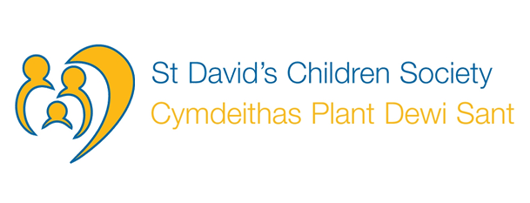

An exciting opportunity has arisen to join the administrative team at St. David’s Children Society. The successful post holder will work in a supportive and flexible working environment with a strong emphasis on individual and team development. Generous terms and conditions apply.

Administrator – St. David’s Children Society
37 hours
Salary: £18,870 – £21,074 SCP 18-22
Fixed Term for 2 years

St. David’s Children Society is a vibrant and thriving Voluntary Adoption Agency providing adoption services across Wales and Herefordshire. St. David’s is a key partner in the National Adoption Service.

We require an energetic and forward-thinking administrator to work alongside the administrative team in the Cardiff office. The successful applicant will initially offer administrative support to an innovative project ‘Adopting Together’. Applicants must have a minimum of 2 years’ experience with high level competence in Word, Excel and PowerPoint.

Closing date for applications is 31st January 2019. Interviews to be held on 12th February 2019

For an informal discussion contact Anna Nyamhotsi, Mel Oates or Singeta Kalhan Gregory Tel 02920 667007 or email info@stdavidscs.org X X0XX0

Job Description
Application Form

