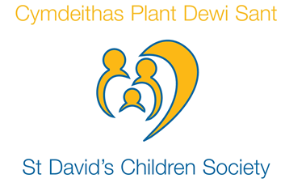
ST DAVID’S CHILDREN SOCIETY

Senior Social Worker Adoption.

Salary: £ 34,788 - £36,876

2 Full time permanent posts (37 hours/week)

An exciting opportunity has arisen to join St David’s Children Society; a vibrant, award winning and established Voluntary Adoption Agency providing adoption services across Wales.

We require a creative and forward thinking registered social worker with at least 3 years post qualifying experience in a child & family setting to join our experienced adoption team. Our office is based in Cardiff, but we would welcome applications from social workers who live further afield given the geographical area we cover. We support flexible working and the post is suitable for a job share.

Duties entail undertaking the full range of adoption recruitment, assessment & child placement activity and post placement / post adoption support.

We provide a supportive working environment with a strong emphasis on individual & team development.

10% pension contribution + comprehensive BUPA cover. St David’s is committed to achieving equal opportunities.

A recognised social work qualification applies.

Closing date for applications is Friday 13 March 2020.

Interview date: 27 March 2020 (Cardiff)

For additional information visit our website or contact: Anna Nyamhotsi, Mel Oates or Martina McCrossan at 28 Park Place, Cardiff CF10 3BA. Tel No: 029 2066 7007 Email: info@stdavidscs.org Website: www.adoptionwales.org

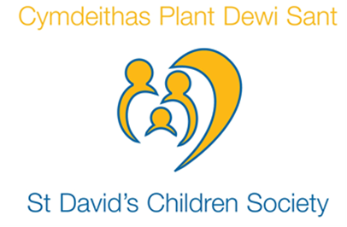

Cymdeithas Plant Dewi Sant
Uwch Weithiwr Cymdeithasol Mabwysiadu
Cyflog: £34,788 - £36,876
Dai safleoedd amser llawn, parhaol (37 awr yr wythnos)
Mae cyfle cyffrous wedi codi i ymuno â Cymdeithas Plant Dewi Sant; rydym yn Asiantaeth Fabwysiadu Wirfoddol fywiog sy’n darparu Gwasanaeth Mabwysiadu ledled Cymru.
Rydym angen Gweithiwr Cymdeithasol creadigol a blaengar sydd a o leiaf 3 blynedd o brofiad mewn mabwysiadu neu leoliad plentyn a theulu i ymuno â'n tîm. Mae ein swyddfa’n lleoledig yng Nghaerdydd, ond byddwn ni’n croesawu ceisiadau o weithiwr cymdeithasol sy’n byw ledled Cymru. Rydym yn cefnogi weithio hyblyg a croesewir ceisiadu am rannu’r swydd.
Mae dyletswyddau'n golygu ymgymryd â'r ystod lawn o weithgarwch recriwtio, asesu a chynorthwyo lleoliadau plant, a cefnogaeth ar ol lleoliad/mabwysiadu.
Rydym yn rhoi swyddfa cefnogol gyda canolbwynt ar datblygiad y tîm a phersonol.
10% cyfraniad pensiwn + yswiriant iechyd BUPA. Mae Cymdeithas Plant Dewi sant wedi ymrwymo i gyfleusterau cydraddol.
Dyddiad cau ar gyfer ceisiadau: Dydd Gwener, 13^{edd} Mis Mawrth 2020
Dyddiad Cyfweliadau: 27 Mis Mawrth 2020 (Caerdydd)
Os hoffech wybod mwy cysyllter â Anna Nyamhotsi, Melanie Oates neu Martina McCrossan yn 28 Park Place, Caerdydd CF10 3BA. Ffôn: 029 2066 7007. E-bost: info@stdavidscs.org. Gwefan: www.adoptionwales.org.

