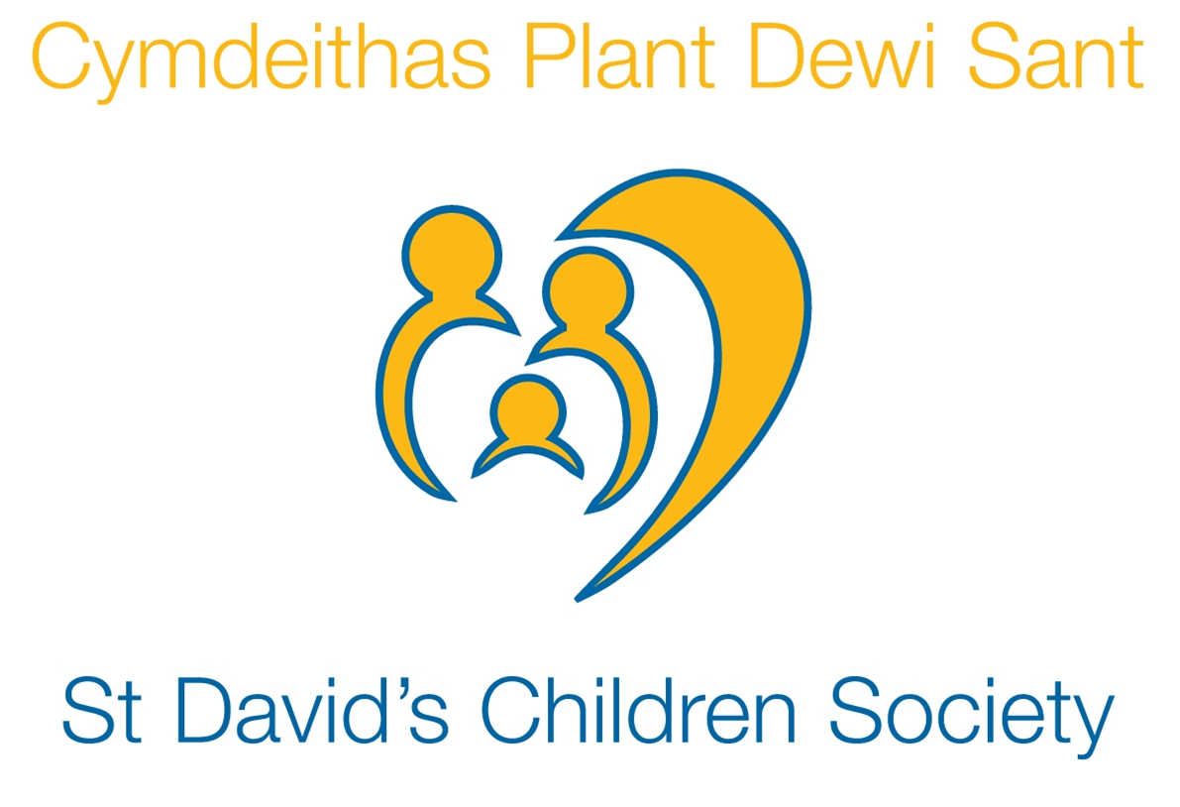

Charity Gift Aid Declaration

Boost your donation by 25p of Gift Aid for every £1 you donate

Gift Aid is reclaimed by the charity from the tax you pay for the current tax year. Your address is needed to identify you as a current UK taxpayer.

Please complete this form and return it to: Business Development Manager, St David’s Children Society, 28 Park Place, Cardiff, CF10 3BA or Email: fundraisingsupport@stdavidscs.org

I want to Gift Aid my donation of £_________________ and any donations I make in the future or have made in the past 4 years to:

St David’s Children Society (Reg. Charity No. 509163)

I am a UK taxpayer and understand that if I pay less Income Tax and/or Capital Gains Tax than the amount of Gift Aid claimed on all my donations in that tax year it is my responsibility to pay any difference.

Donating by Bank Transfer
You can transfer money directly to St David’s using the details below and complete and return this form for the donation to include Gift Aid.
Bank Name: Barclays Bank
Sort Code: 20-18-17
Account Number: 93426580
Account Name: St David’s Children Society

Donating by Cheque
Cheques should be made payable to St David’s Children Society and should be returned with this form.

My Details

Title __________ First name or initial(s) _____________________________________

Surname_______________________________________________________________

Full Home Address _________________________________________________________

___________________________________________________________________________

Postcode _________________________________ Date ___________________________

Please notify the charity if you:
- want to cancel this declaration
- change your name or home address
- no longer pay sufficient tax on your income and/or capital gains

If you pay Income Tax at the higher or additional rate and want to receive the additional tax relief due to you, you must include all your Gift Aid donations on your Self-Assessment tax return or ask HM Revenue and Customs to adjust your tax code.

Keeping in touch: Your support helps St David’s provide our ongoing service and support. We’d love to keep in touch with you to tell you about our work and how you can support it.
Please tick the relevant box if you’d like to receive information by:

☐ email – Please provide email address - ____________________________________________________
☐ post
We will only ever contact you by email or post.

For further details about how we use and protect your information, please view our fundraising privacy policy at www.adoptionwales.org. You can change your contact preferences, request a copy of our privacy policy or ask any questions by contacting fundraisingsupport@stdavidscs.org

